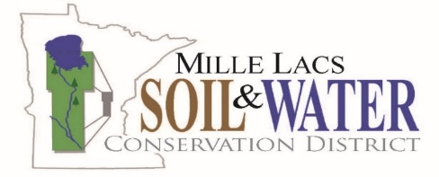
Tree Planting Bar Use Agreement

Borrower Information
Name: ________________________________________________
Phone: ____________________________ Email: ____________________________
Mailing Address: ____________________________________________________________

Borrowing Dates
Pick-up Date and Time: _________________________________________
Return Date and Time: __________________________________________
Rental Dates
Pick-up Date and Time: _________________________________________
Drop-off Date and Time: ________________________________________
Agreement Terms
By signing below, the Borrower and the District agree to the following terms:

1. Scheduling and Use Period
- Use of the tree bar(s) must be scheduled at a time that works for both the Borrower and the District.
- The standard borrowing period is up to seven (7) days, unless otherwise approved in advance by the District.
2. Pick-up and Drop-off Requirements
- Pick-up and return must occur during regular business hours: Monday through Friday, 8:00 a.m. to 4:30 p.m.
- The exact pick-up and return dates and times must be scheduled with the District in advance.
3. District Responsibility and Delays
- The District is not responsible for delays caused by:
  - Equipment failure or breakage, or
  - Late return of equipment by another borrower.
4. Deposit Requirement
- A refundable deposit of $100 per tree bar (cash or check) is required at the time of pick-up.
- The deposit will be returned in full if the tree bar(s) is returned on time and in good condition.
5. Damage, Misuse, or Neglect
- If the tree bar(s) is damaged due to misuse, abuse, or neglect, the Borrower may forfeit part or all of the deposit.
- The amount withheld will be based on the cost of repair or replacement, as determined by the District.
6. Late Return Fee
- A late fee of $14 per day will be charged if the tree bar(s) is not returned by the agreed-upon date.
- If the tree bar(s) is more than seven (7) days late, the District may retain the full deposit.

Signatures
By signing below, both parties confirm that they understand and agree to the terms of this agreement.
____________________________ _____________ _______________________________ __________
Borrower Signature Date District Signature Date

