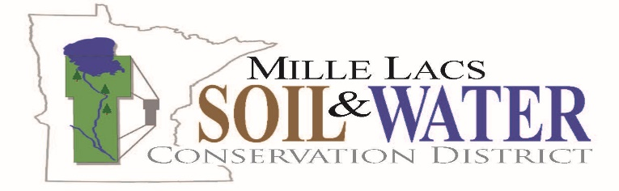
The mission of the Mille Lacs Soil & Water Conservation District to assist area people with soil and water resource management.
Historic Courthouse
635 2nd St SE, Milaca, MN 56353
320-983-2160
www.millelacsSWCD.org
Regular Board Meeting – Updated Agenda
Mille Lacs County Historic Courthouse, Conference Room D
Wednesday, December 13, 2017 – 6:00pm

- CALL TO ORDER
  - Pledge of Allegiance to the flag
- Approval of Agenda – new business, reports, or additions (action)
- Conflict of Interest Disclosure
- Approval of Minutes – November 8, 2017 regular Meeting Minutes (action)
- Open Public Forum: Board policy limits public forum time for board meeting topics not scheduled within the agenda to 10 minutes, but allows time extension by vote.
- Staff Report/Presentation
  - NRCS Report (written report) – Civil Rights/EEO Review
  - Staff Report (written report)
    - Project Summaries (written report) – Buckthorn Symposium
    - News Releases (written report) – Pettit Pastures
  - Administrator Report
  - MAWQCP Report (written report)
- District Policy & Planning
  - Personnel Committee
  - Strategic Planning/Annual Work Plan
  - Policies/Resolutions
    - Conservationist of Year / MASWCD Convention
    - Consent Agenda
- Financial
  - Monthly Financial Report
    - November Treasurer’s Report (action)
    - Checks written 6786 – 6809 & electronic transfers #e17-072 - #e17-079 (action)
  - Statement Audit
  - Lease Agreement – Will be available at meeting.
  - Financial Committee Reports – 2018 Draft Budget
- Grant & Project Decisions
  - Grant Application
    - Conservation Corps MN and Iowa Youth Crew Grant – SWCD assisting Timber Bay Camp in applying for a crew to remove weeds and invasive turf grasses and planting of natives, also providing project supervision. (action)
    - Conservation Corps MN Grant – Apprentice. (information)
    - Noxious Weed and Invasive Plant Grant (information)
  - Contracts
    - Cost-Share Application (#P16-7) to seal well for Tim Kofstad in the amount not to exceed $500.00 based on 50% of the estimated eligible cost of $1,000.00. (action)
    - Project Completed, Approval of Payment. Contract #P16-2378-1-LC-1 to seal two wells for James Vedders in an amount not to exceed $1,400.00 based on 50% of the estimated eligible cost of $2,800.00; using 2016 Local Capacity Funds (action)
    - Project Completed, Approval of Payment. Contract #FY16-4 for Rodney Jones on a Water Diversion Project in the amount of $2,916.63. (action)
    - Project Partially Completed, Approval of Partial Payment. Contract #FY17-1 for Fransen Wetland Restoration Repair in the amount of $1,837.49. Approval of partial payment pending TSA Technical Certification signature (action)
- District Activities
  - Water Plan – Mille Lacs County Priority Concerns Scoping Document
- Informational Updates
  - Water Management & Watershed Activities
    - Mille Lacs Lake Watershed Management Group
    - Snake River Watershed Management Board
  - Supervisor Updates
    - Service Awards
    - MN SWCD Forestry Association (Eller)
    - Area III/TSA Report (Hoefert, Area Director)
    - MASWCD Board (Beckstrom, MASWCD President)
    - Clean Water Council (Hoefert, Farm Organization Representative)
    - Conservation Meeting with Sen. Mathews (Eller & Janski)
- Meetings & Events
  - SWCD Personnel Committee Dec. 12, 2pm, SWCD
  - Conservation Meeting with Senator Mathews Dec. 14, noon, Farm Market Café
  - MASWCD Legislative & Resolutions Committees Dec. 19, Metro Area(TBD)
  - SWCD Integrated Roadside Vegetation Management Committee Dec. 26, 10am, SWCD
  - TSA Area 3: Jan. 24, 10am, Duluth
  - Mille Lacs Lake Watershed Management Group: Jan. 25, 10am, Onamia
  - 2018 Road Salt Symposium: Feb. 8, 8:30-2:45, Plymouth Creek Center

- Evalute the Meeting
- Next Regular Meeting – Wednesday, January 10, 2018, 6:00pm, Historic Courthouse, Conference Room D.
- Adjourn

